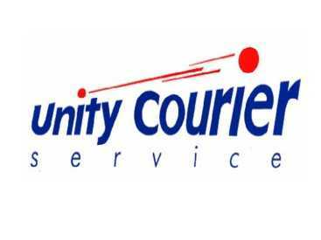

Unity Courier DST Quick Start Guide
If you have any questions, or need any assistance please contact support at 800-992-8890 ext 7609.
  - To generate labels on Unity Courier’s shipping system “Direct Shipping and Tracking (DST)”:
- Go to the website you signed up for an account on: dst.unitycourier.com

- Enter the account number you received in the e-mail confirming your account activation, the e-mail and password you used when you completed the sign up process.
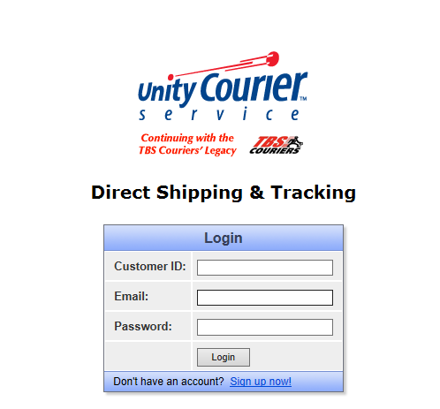

- The screen below will be displayed. This is your dashboard or home screen.

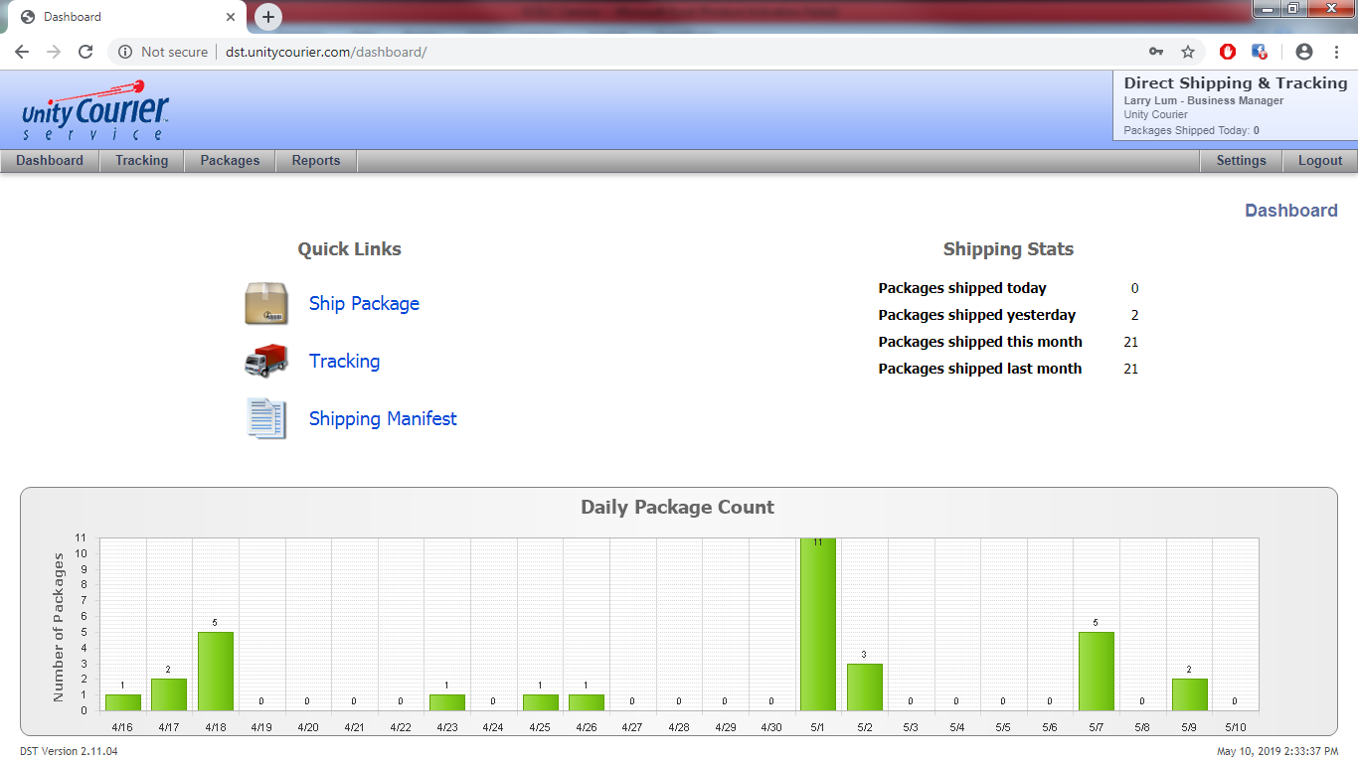

- Click Ship Package. 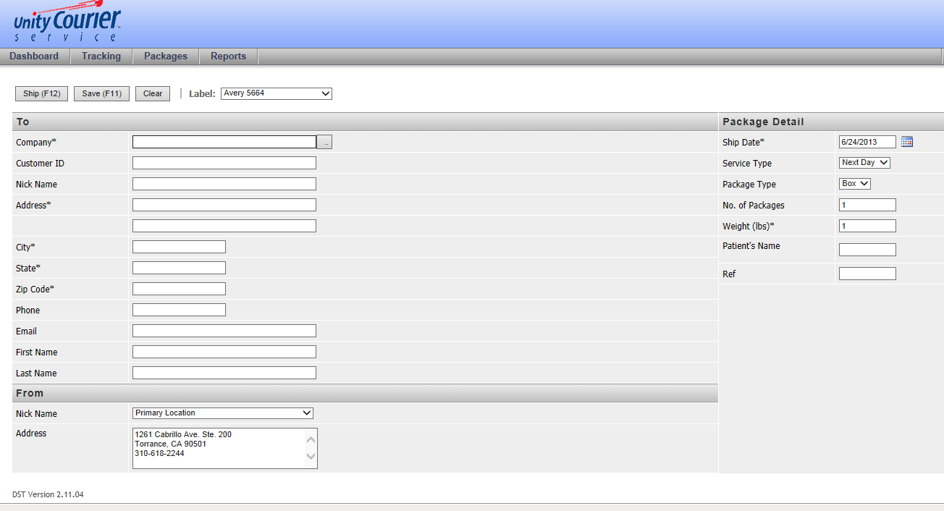

On this screen you only need to fill in the fields with an “*”.
Company: enter the first three letters of the location you are shipping to. A drop down box will appear with the different addresses available. Once you select the location you want to
ship to the remaining address fields will automatically fill in.
Ship Date: defaults to today’s date.
NOTE: If you are shipping multiple packages, this will be the ship date for all your labels until the package is picked up. At that time the ship date will update to the date the package was picked up.

Service Type: defaults to “Next Day”.
Package Type: defaults to “Box”. If you need additional types, please contact support to have them added to your selectivity.
No. of Packages: defaults to “1”.
If you want to print multiple labels at the same time, change this number to the quantity of labels you want to print.

Weight: defaults to “1”. This is the weight for the box. If you are printing multiple labels, you will get a weight field for each package.
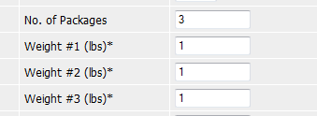
Reference: This field isn’t required. If you want to have a reference print on the label enter the information here.
- Once everything has been filled in, you’re ready to print the label.
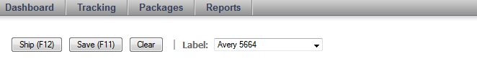

At the top of the screen you have some options.

Ship (F12): Clicking this button will generate the label in a pdf format.

Save (F11): Clicking this button will save your label to be printed later. To print saved labels as a batch, go to Packages -> Saved Shipments to print your labels.

Clear: Clicking this button will clear the screen and let you start over.

Label: This will default to letter which prints one label per sheet of paper. If you want to print multiple labels on a sheet, you can click on the arrow to the right. This will provide a drop down box. If you choose “Avery 5664” you will get 6 labels on a sheet of paper. You can also use Avery labels, either 5664 or 5164 formats will work. Other templates available are Zebra 4x3, Zebra 4x6 Landscape, Zebra 4x6 Portrait (standard UPS size), and Zebra 4x7 (standard Fedex size).

- Once you click F12 your label will be generated. It will display under a second tab on your internet browser. Sometimes the second window is shown behind your Ship Packages window.

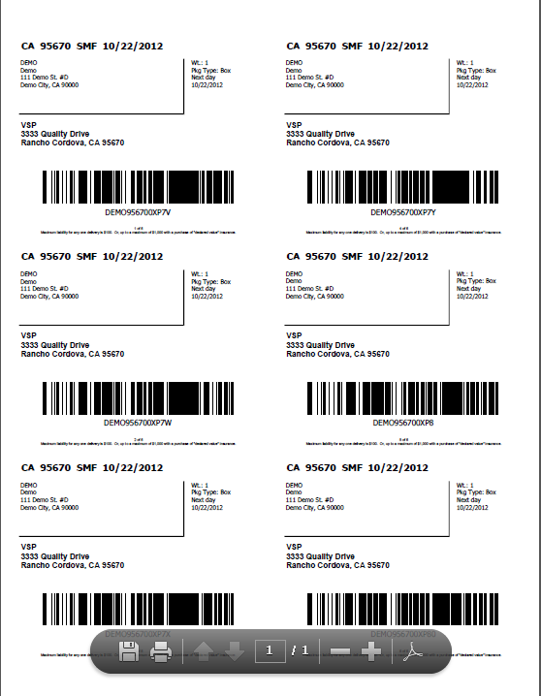

This will display the label format you selected. The example above is Avery 5664. Print the label. It can print to any laser printer.

If you have a regularly scheduled driver, they will pick up the box at the scheduled time. If you do not have a regular pick up time, you can request a pick up by calling 800-992-8890.

